Meaning of the Time as forecast from the Heart of Sky, and the Mayan calendars.
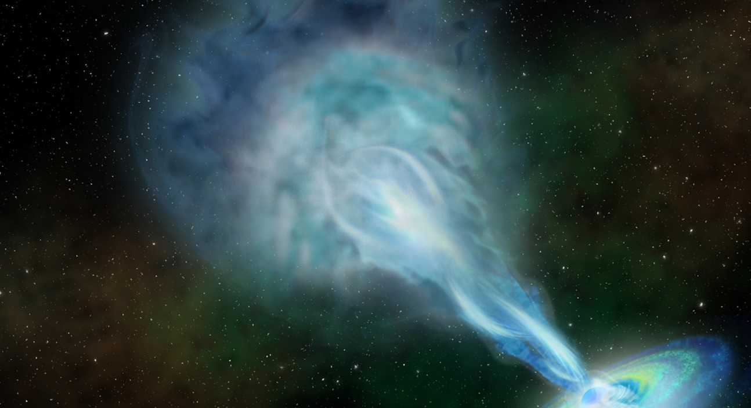
Quasar, Radio image 13 Billion Light Years from Earth
Greetings Beloved Kin,
This is critical juncture marked on all scales of Time. The Moon completed a once-in-18-year wobble and finding the balance of her new perspective. Waters stirred up turned the tides, and all things on Earth are also being restored to a new equilibrium. Fates lean toward the "water that rests within the balance of Love." When we witness love our heart's resting beat is 432hz, rising to 528hz when we're moved in the balance. You can look to any scale. Science, music, or even the scale public opinion - MUST agree, if you've discerned DIVINE Truth on the scale of Universal Law.
We are about to stand up straight again, wholly by our own power from the Moon's adjustment and new perspective on Earth.
What I've had time to track - January 14th and 15th were marked for DIVINE Insight and the JOY of KNOWING. Then, the 19th - maybe more Truth than we wanted to know, we were just being prepared to see - while we could still remember a TRUTH of ANSWERED PRAYERS.
The Global Burner, 4 Eagle/MEN (January 18, 2022) turned my thoughts to it. At the center of every season "we blow" - a release of all the residual energy from the past. WE resume our equilibrium and "resting face" - whatever that may be.
It's a chance when LOVE can be seen as the TRUTH on our face, and shine from everything we do on behalf of the whole. LOVE is the POWER we were given. If we ever believed in the Power of Love, now's the time to be wholly invested in the Truth and APPLY it to EVERYTHING. NO HUMAN idea has a chance, when it's a CREATION OF THE POWER OF LOVE - the Beauty of it stops us in our tracks. The Love we Dream of the most is Love that's Lost that COULD be found. Some way.
The Light at the Center shines equally on everything. The "heart of sky" - the space between us, rules the Balance. The ONE is the beginning of the Fibonacci sequence, a pattern defined by the first 3 steps, and 3's multiply exponentially to the Nth degree to start again. Something makes a rock stick together to be something else, joined together. We have IRON in our veins. Steel was forged from Iron with carbon and time, repeating a pattern that Love carried to the Nth degree -Truth at all cost to our Ego.[/caption]
4 Eagle/MEN offers Wings that fly on the Truth to offer a glimpse of the future. When the smoke and scent of copal fills the air, EVERYONE REMEMBERS someone is praying for them Here and Now. What would you do? There's a CHOICE of Divine Trinity.
Take heed. We're ALL under pressure. If you are turning to the One, you are a Light for the Whole - the Living Witness that's WILLING to SEE on behalf of the whole. We may see more than we ever wanted to know, but we can - asking for Truth at all costs. To shine the Love that everyone thinks we lost. It's still waiting. It still LOOKS THE SAME - like LOVE and not WAR. We know the Truth - how Love looks.
Our sparks are in single-file in the circle passing through to the "other side" of Love. The BEAUTY of our OPPOSITE reflection on the darkness is about to GO OFF as the FIRST LIGHT of an even bigger fireworks show in 2023. (Another USA total solar eclipse, marks an end of a cycle with an X - crossing the path of the Solar Eclipse that changed the meaning of time in 2017, before the Moon wobbled.
We'll remember this "grand finale" and we won't forget. The Mayan priest leads us through the Haab year beginning 03/31/2022. We'll hold the frame of mind of Vigilant Consciousness, to watch our back and to remember the place where we KNOW the Divine Truth. The Deer builds the pillars of Faith to stand from Truth of Common Sense.
We can stand up during a day or two, if Truth is more than we expected to see on January 19. We'll be in the state of mind and Peace Beyond Understanding. And, everyone else will REMEMBER... Life was better when we Loved before. We weren't perfect, but it was getting better - and Love is better than War. The DIVINE LIGHT always makes Perfect Sense - COMMON sense between us. Opinions don't matter when we love. We NEVER expect anyone to see things EXACTLY the same way.
love, in lak'ech, Debra
PS - The astrologer youtube links are offered on the astrology page, that lead to their latest forecasts.

2 Reed/BEN (Cherokee, Reed/I’HYA)
Galactic Tone 2: Mysterious as the question ‘to be or not to be?” Two is the recognition of the separation of self from all else and the desire to be rejoined. Walking a balance while making choices of all kinds, light/dark, male/female, good/bad, Yin/Yang, is the energy of this number. Experiencing the differences between one and another is the use and purpose of this number.
Reed/BEN: Reed persons are the spiritual essence, protectors and guiding light for family and home. They are competent speakers who will take up a cause. Very tough and analytical, Reeds endeavor to bring peace, harmony and order to all o their relations. Reeds are blessed with great skill at negotiations and consoling which are very often put to the test. Although Reeds need a lot of appreciation, may have marriage or business problems because of inflexible vies and high expectations, which erode affinity. The lesson for Reed is to be like a garden hose, not a steel pipe. Bless or repair your house.
Cherokee, Reed/I’HYA: REED- Symbol-Reed is the Earth, reflection of the Star Chaga of Pollux. Reed made up the Magician Twins who led the journey to bring back to life the daughter of the Sun. The Casket is Gemini. Energy for Intellectual minds, creation, re-creation, new directions, breaking the ties that bind. A trailblazer and leader. From the East, direction of success and happiness, no matter what route is taken, always ending up in the Light.

